CASE STUDY BASED ASSIGNMENT
CASE STUDY: Deploy a Containerized Application using Docker.

PRE-REQUISITS:
1. System Requirements:
- A Linux machine (Ubuntu, Debian, Fedora, etc.) or a VM with Linux.
- Sudo/root access to install packages.
- Stable internet connection.
2. Installed Software:
- Docker: It is a tool that is used to automate the deployment of applications in lightweight containers so that applications can work efficiently in different environments in isolation.
- Text Editor or IDE: It is a tool to edit the Dockerfile and source files of the web application. Tools like VS Code, Nano or Vim can be used.
- Web Browser: It is a browser to test the web application after deployment.
3. Web Application: An application required to containerize and deploy on Linux.

STEPS:
Step 1: Create and set up a web application locally with a basic route that renders an HTML template. A python-based web application is used to containerize and deploy.
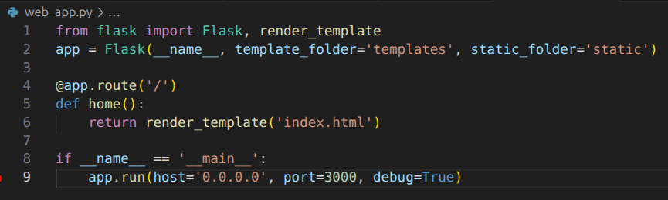
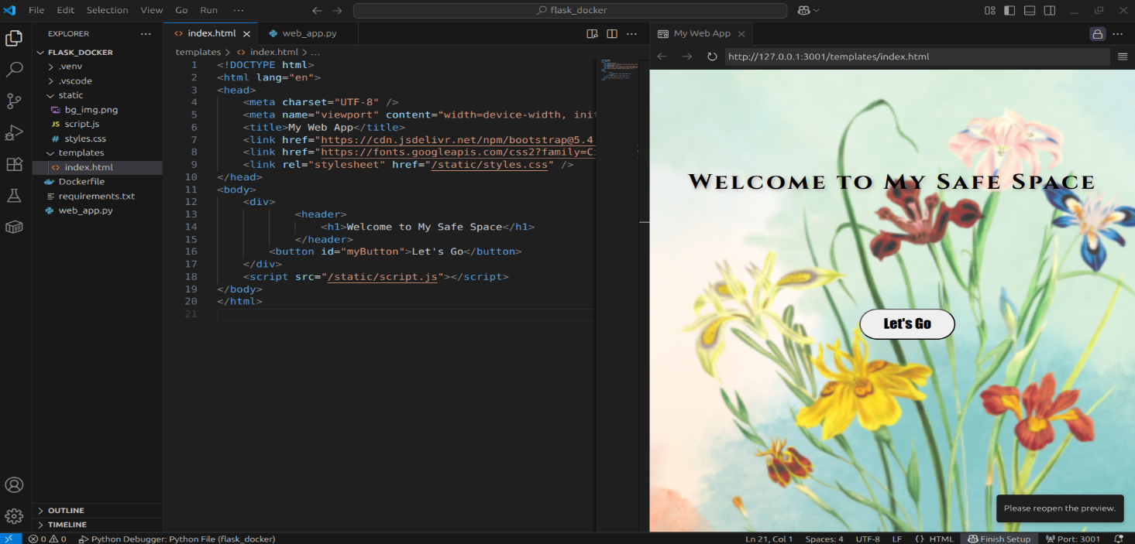
Step 2: Include a requirements.txt file in the base directory to keep track of all the external python packages used in this application. When the Docker will deploy this on a server, the Dockerfile or deployment scripts will use requirements.txt to install dependencies automatically inside the container or environment.
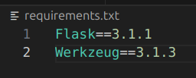
Step 3: In the base directory of the web application, create a file called Dockerfile with no extension. This file contains instructions for building a Docker image. It ensures the correct Python version, installs dependencies, and copies the application into the image. In the file, input the following:
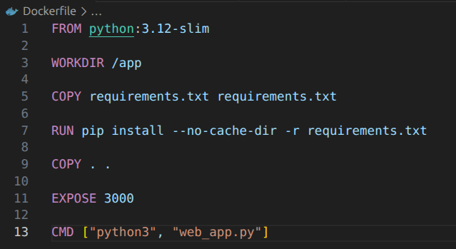
Step 4 (Optional): Create a virtual environment for Python and install dependencies in it locally. The virtual environment should be created in the base directory of the web application. This virtual environment ensures that dependencies for this project do not conflict with other Python projects on the system. The virtual environment can be deactivated using the command “deactivate”.
Syntax: python3 -m venv [virtual_environment_name]
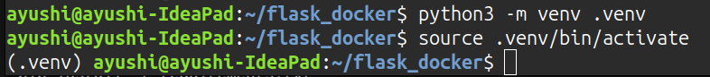
Step 5: Build the docker image in the /app directory that was created in the Dockfile file. This /app will contain the web application to be deployed into Linux. Building the image packages your app, Python, and all dependencies into a single file that can run anywhere without worrying about local setup.
Syntax: docker build -t [image_name] .
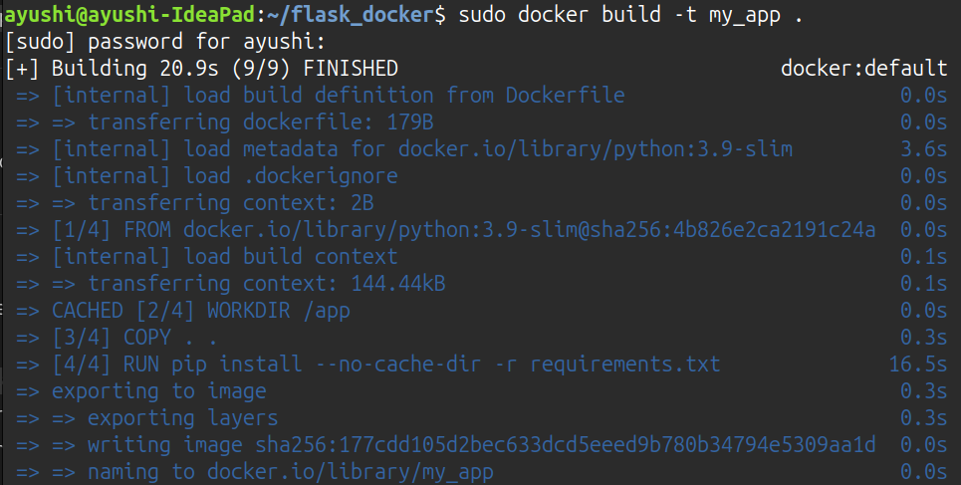
Step 6: Once the docker image is created, the docker can be ran using the port that was provided in the python file and exposed port in the Dockfile. Running the container launches the app in an isolated environment. The -p flag maps the container port to your local machine port so you can access it via browser.
The container can be either run normally where it auto-starts the app, or it can be run interactively for debugging where it opens a shell inside the container and then the app can be run manually.
Syntax: docker run -p [host_port]:[container_port] [image_name]
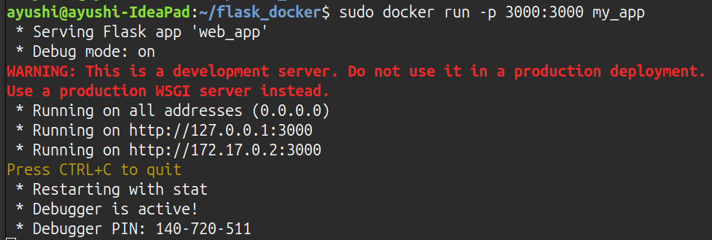
Syntax: docker run -it -p [host_port]:[container_port] --entrypoint /bin/bash [image_name]
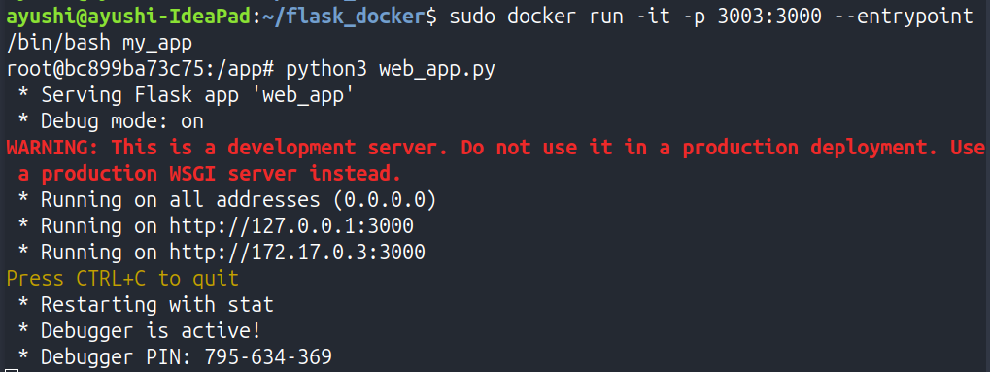
Step 7: After the /app launches, the web application can be accessed using the container or the port. Simply, click on either two of the local host address or the local network ip given below and the link will redirect the user to the web page of the application.
Syntax: python3 [python_file]
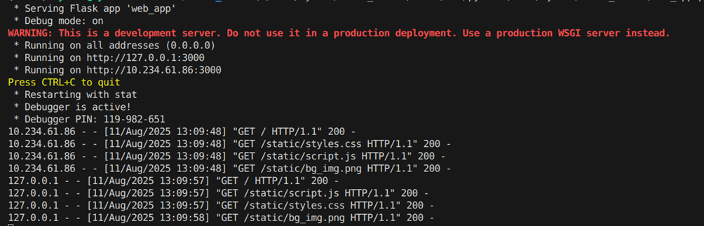
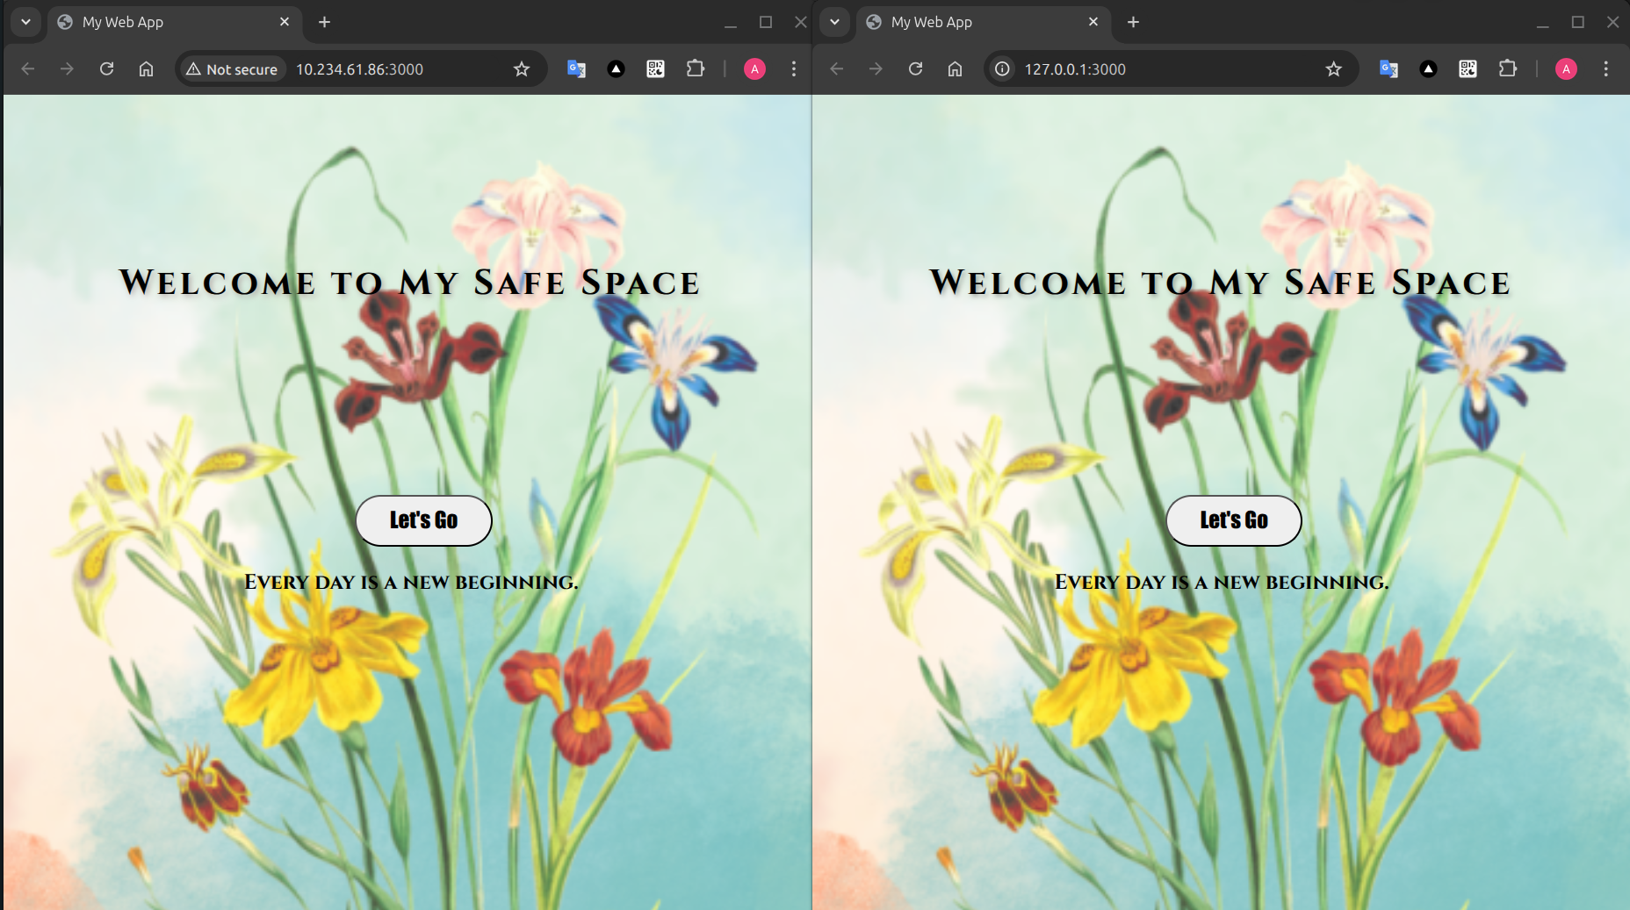
Step 8: Since the docker has containerized the content on the web application in the app directory, it can be loaded using the container ID. The container ID can be found using a command that shows all possible running IDs. An exited ID can be started again and then executed.
Syntax: docker ps or docker ps -a
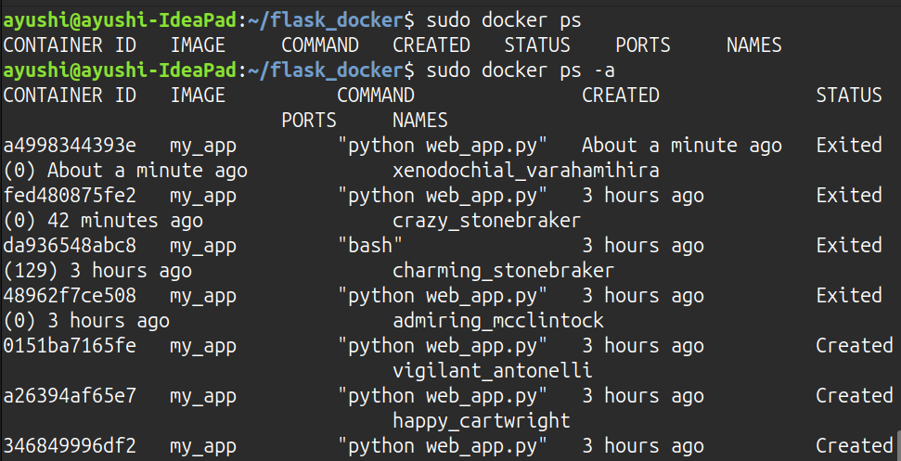
Step 9: Once the container ID is known, it can be used to view logs or execute commands in it like accessing or managing the container.
Syntax: docker exec -it [container_id] /bin/bash
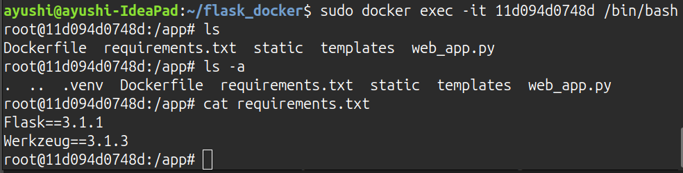
Syntax: docker logs [container_id]
